Software Architecture
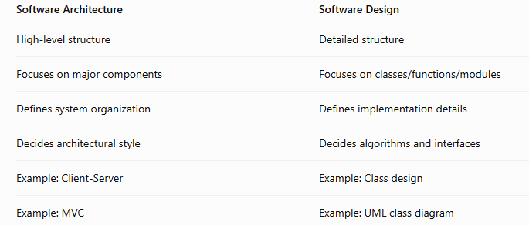
The software architecture of a program or computing system is the structure or structures of the system, which comprise software components, the externally visible properties of those components, and the relationships among them.”
- Architecture is not the operational software.
- It is a representation that enables you to:
  - Analyze the effectiveness of the design in meeting requirements
  - Consider architectural alternatives at a stage when changes are still relatively easy
  - Reduce the risks associated with the construction of the software
Architecture shows the overall structure of the software — the major components and how they interact with each other
Why is Architecture Important
• Communication
Representations of software architecture enable communication between all parties (stakeholders) interested in the development of the system.
• Early Design Decisions
The architecture highlights early design decisions that will have a profound impact on all software engineering work that follows and on the ultimate success of the system.
• Intellectual Manageability
Architecture constitutes a relatively small, intellectually graspable model of how the system is structured and how its components work together.

Architectural Styles
An architectural style describes a system category that encompasses:
- A set of components (e.g., database, computational modules)
- A set of connectors that enable communication, coordination and cooperation
- Constraints that define how components can be integrated
- Semantic models that enable a designer to understand the overall properties of the system

Data-Centered Architectures

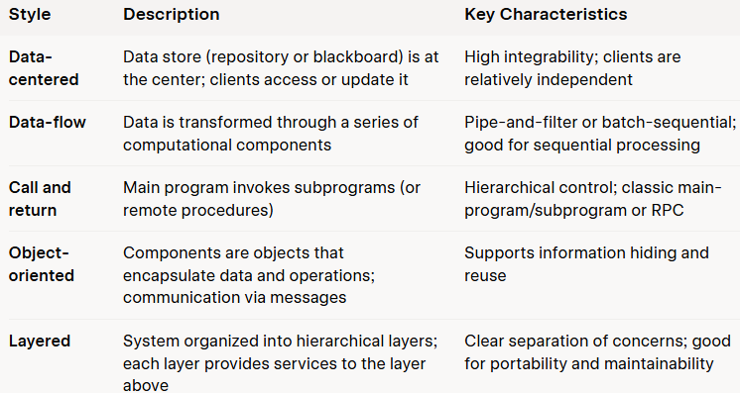
- A data store (file or database) resides at the center.
- Clients access the data store independently.
- Promotes integrability (new clients can be added easily).
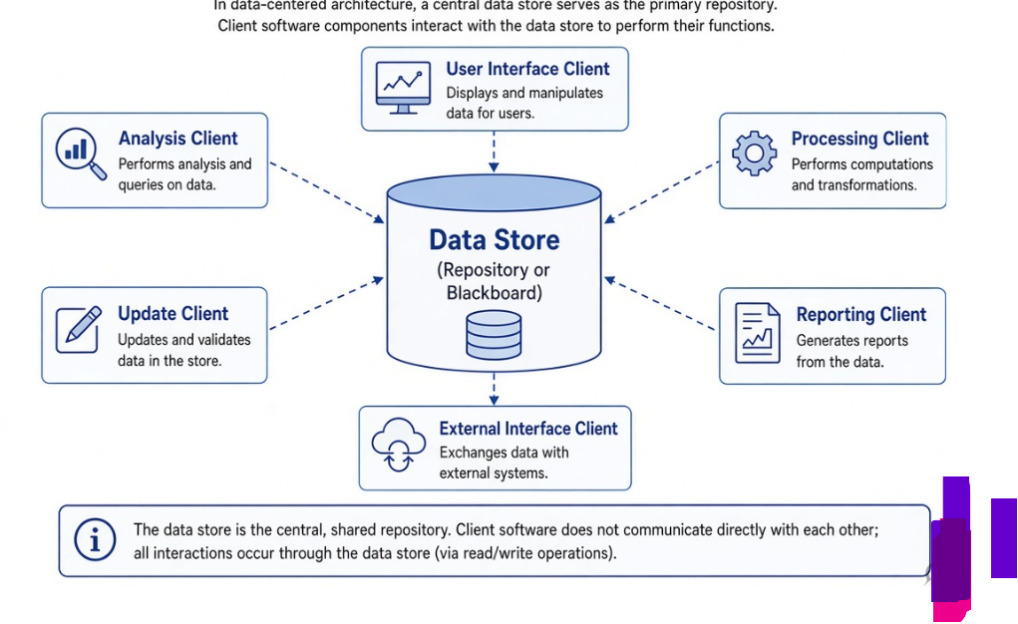

Data-Flow Architectures (Pipe-and-Filter)
- Input data is transformed through a series of computational components (filters).
- Filters are connected by pipes.
- Each filter works independently.
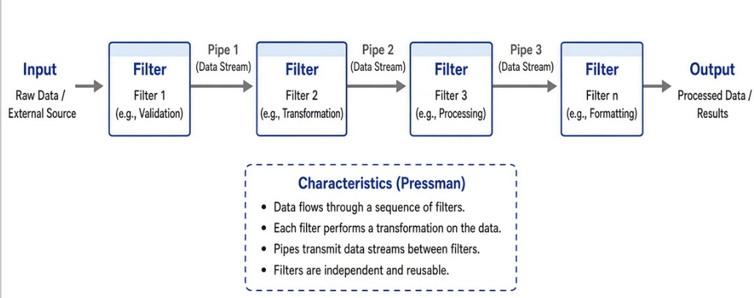

Call and Return Architectures
Two sub-styles:
- Main program / subprogram architecture (classic hierarchical structure)
- Remote procedure call architecture (components distributed across network)

Object-Oriented Architectures
- Components encapsulate data and the operations that manipulate the data.
- Communication is accomplished via message passing.

Layered Architectures
- Number of different layers are defined.
- Each layer accomplishes operations that progressively become closer to the machine instruction set.
- Outer layer: User interface operations
- Inner layer: Operating system interfacing

Architectural Patterns
- Concurrency — How the system handles multiple simultaneous tasks (e.g., operating-system process management, task scheduler patterns).
- Persistence — How data survives beyond the execution of the process that created it (database management or application-level persistence).
- Distribution — How components communicate across a network (e.g., the broker pattern that acts as a middle-man between client and server components).

Architectural Design Process
- Represent the system in context
Use an Architectural Context Diagram (ACD) showing:
- Superordinate systems- Higher-level systems that use the target system as one part of a larger processing scheme. (The target system is a subordinate component of these systems.)
- Subordinate systems- Lower-level systems that the target system uses. They supply data or processing that the target system needs to complete its own functionality
- Peer-level systems- Systems that interact with the target system on an equal footing (peer-to-peer). Information is freely produced or consumed by both sides.
- Actors- People or devices that interact with the target system by producing or consuming information required for its processing.
- Define Archetypes
Archetypes are abstract building blocks of the architecture.
Example (SafeHome): Controller, Node, Detector, Indicator
- Refine the architecture into components
Identify top-level components that address major functionality.
- Describe instantiations of the system
Show how the architecture is realized in a specific environment.

Assessing Alternative Architectural Designs
Architecture Trade-off Analysis Method (ATAM) developed by SEI:
- Collect scenarios
- Elicit requirements, constraints, and environment description
- Describe the architectural styles/patterns chosen
- Evaluate quality attributes
- Identify sensitivity of quality attributes
- Critique candidate architectures

Architectural Mapping Using Data Flow
For Call-and-Return architectures, describes Transform Mapping:
- Review the fundamental system model (Level 0 DFD)
- Review and refine DFDs
- Determine transform or transaction flow characteristics
- Isolate the transform center
- Perform first-level factoring
- Perform second-level factoring
- Refine the architecture using design heuristics
- A Brief Taxonomy of Architectural Styles

A Brief Taxonomy of Architectural Styles
An architectural style describes a system category that encompasses:
- A set of components (e.g., a database, computational modules) that perform a function required by the system
- A set of connectors that enable “communication, coordination and cooperation” among components
- Constraints that define how components can be integrated to form the system
- Semantic models that enable a designer to understand the overall properties of a system by analyzing the known properties of its constituent parts
An architectural style is a transformation imposed on the design of an entire system. The intent is to establish a structure for all components of the system.

1. Data-Centered Architectures
A data store (e.g., a file or database) resides at the center of this architecture and is accessed frequently by other components that update, add, delete, or otherwise modify data within the store.
- Client software accesses a central repository.
- In some cases the data repository is passive (clients access data independently).
- In other cases a blackboard mechanism is used (the blackboard actively coordinates the transfer of information between clients).
Key advantage: Promotes integrability. Existing components can be changed and new client components can be added without concern about other clients (because the client components operate independently).

2. Data-Flow Architectures
This architecture is applied when input data are to be transformed through a series of computational or manipulative components into output data.
- The classic form is the pipe-and-filter pattern.
- A set of components called filters are connected by pipes that transmit data from one component to the next.
- Each filter works independently of those components upstream and downstream.
- A filter is designed to expect data input of a certain form and produces data output of a specified form.
- The filter does not require knowledge of the workings of its neighboring filters.

3. Call and Return Architectures
This architectural style enables a program structure that is relatively easy to modify and scale. Two important substyles exist:
- Main program/subprogram architectures
Classic program structure that decomposes function into a control hierarchy. A “main” program invokes a number of program components, which in turn may invoke still other components.
- Remote procedure call architectures
The components of a main program/subprogram architecture are distributed across multiple computers on a network.
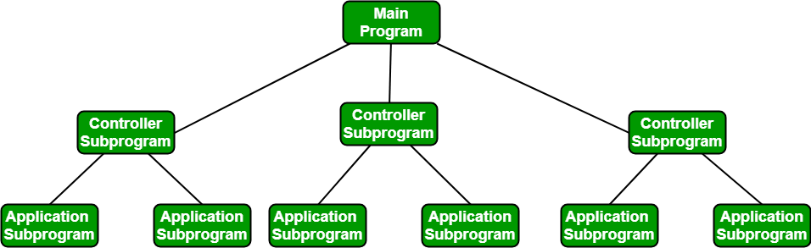

4. Object-Oriented Architectures
The components of a system encapsulate data and the operations that must be applied to manipulate the data.
Communication and coordination between components are accomplished via message passing.
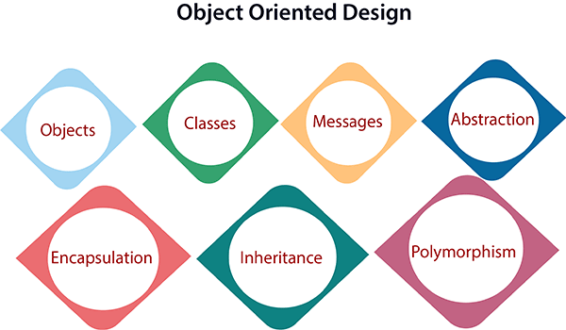
- Objects: All entities involved in the solution design are known as objects. For example, person, banks, company, and users are considered as objects. Every entity has some attributes associated with it and has some methods to perform on the attributes.
- Classes: A class is a generalized description of an object. An object is an instance of a class. A class defines all the attributes, which an object can have and methods, which represents the functionality of the object.
- Messages: Objects communicate by message passing. Messages consist of the integrity of the target object, the name of the requested operation, and any other action needed to perform the function. Messages are often implemented as procedure or function calls.
- Abstraction In object-oriented design, complexity is handled using abstraction. Abstraction is the removal of the irrelevant and the amplification of the essentials.
- Encapsulation: Encapsulation is also called an information hiding concept. The data and operations are linked to a single unit. Encapsulation not only bundles essential information of an object together but also restricts access to the data and methods from the outside world.
- Inheritance: OOD allows similar classes to stack up in a hierarchical manner where the lower or sub-classes can import, implement, and re-use allowed variables and functions from their immediate superclasses.This property of OOD is called an inheritance. This makes it easier to define a specific class and to create generalized classes from specific ones.
- Polymorphism: OOD languages provide a mechanism where methods performing similar tasks but vary in arguments, can be assigned the same name. This is known as polymorphism, which allows a single interface is performing functions for different types. Depending upon how the service is invoked, the respective portion of the code gets executed.

5. Layered Architectures
A number of different layers are defined, each accomplishing operations that progressively become closer to the machine instruction set.
- Outer layer — components service user-interface operations
- Intermediate layers — provide utility services and application software functions
- Inner layer — components perform operating-system interfacing
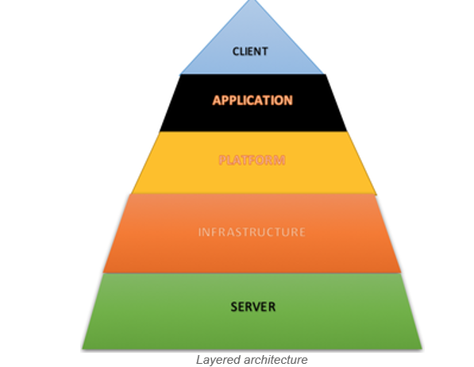
These five styles are only a small subset of those available. Once requirements engineering uncovers the characteristics and constraints of the system to be built, the architectural style (or combination of styles/patterns) that best fits those characteristics and constraints can be chosen.

For example, a layered style (appropriate for most systems) can be combined with a data-centered architecture in many database applications.

Note on Architectural Patterns vs. Styles :
An architectural pattern also imposes a transformation, but differs from a style in three ways:
- Its scope is narrower (focuses on one aspect of the architecture).
- It imposes a rule on how the software handles some aspect of functionality at the infrastructure level (e.g., concurrency).
- It tends to address specific behavioral issues within the context of the architecture.
Patterns are frequently used in conjunction with an architectural style.
Component-Level Design
Component-Level Design is an important stage of software design in which the internal details of each software component are specified before implementation. The following notes cover the definition, basic design principles, design guidelines, designing traditional components, coding principles and guidelines, incremental development of code, and code inspection planning, with diagrams and examples suitable for classroom teaching and examination preparation.

Component-Level Design: Definition
component-level design defines the data structures, algorithms, interface characteristics, and communication mechanisms allocated to each software component.
A software component is a modular building block of a software system. It performs a specific function and interacts with other components through defined interfaces.
For example, in a college management system, the following may be separate components:
- Student Registration
- Attendance Management
- Examination Management
- Fee Payment
- Report Generation
Each component has its own processing logic, data, and interface.
Diagram 1: Position of component-level design in software development
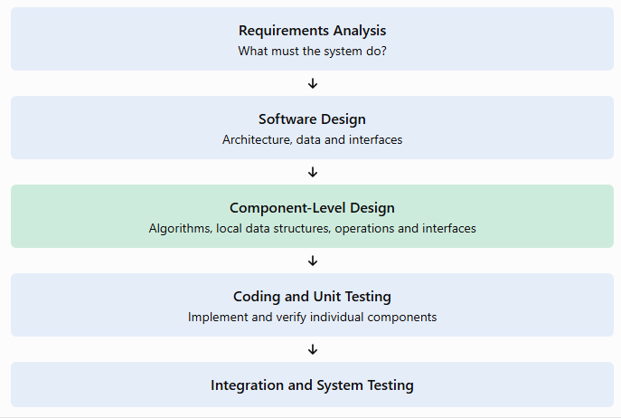

Objectives of component-level design
- Convert the software architecture into detailed component specifications.
- Define the processing logic of each component.
- Specify internal data structures and local variables.
- Define component interfaces and communication with other components.
- Identify errors and design inconsistencies before coding.
- Improve maintainability, reusability, testability and reliability.

Main activities and outputs

Activity | Output
Identify components | Component/module list
Define interfaces | Input, output and operation specifications
Design data structures | Arrays, records, objects or other structures
Specify algorithms | Pseudocode, flowcharts or activity diagrams
Review the design | Corrected component design
Prepare for implementation | Component specification for coding and testing

2. Basic Design Principles
Four important object-oriented design principles are emphasized: Open-Closed Principle, Liskov Substitution Principle, Dependency Inversion Principle, and Interface Segregation Principle.
These principles help designers create flexible components that can be extended and maintained without unnecessary changes.

2.1 Open-Closed Principle (OCP)
Definition: A software component should be open for extension but closed for modification.
This means that new functionality should be added without repeatedly changing the existing, tested code.
Example: Consider a payment system that supports UPI payments. Later, the system must support credit cards and net banking.
A poorly designed system might repeatedly modify one large payment-processing function. A better design defines a common payment interface and implements separate payment methods.
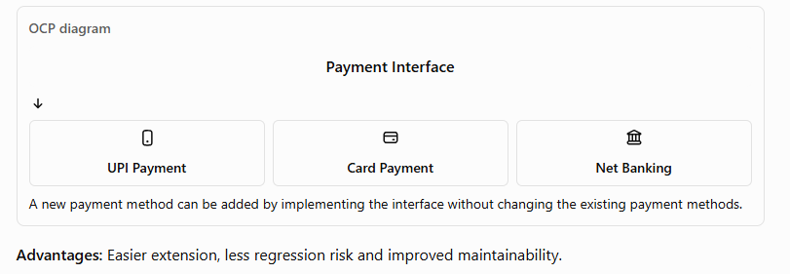

2.2 Liskov Substitution Principle (LSP)
Definition: Objects of a derived class should be usable wherever objects of the base class are expected without breaking the correctness of the program.
A child class must respect the contract and expected behavior of its parent class.
Example: Suppose UPIPayment and CardPayment implement a common PaymentMethod interface. A checkout component should be able to use either implementation through that interface.
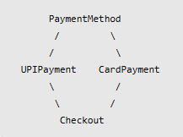
The checkout component should work with either payment method without requiring special internal changes.
Advantages: Supports polymorphism, substitutability and reliable extension.

2.3 Dependency Inversion Principle (DIP)
Definition: High-level components should depend on abstractions rather than concrete implementations.
For example, an order-processing component should depend on a PaymentMethod interface instead of directly depending on a specific UPI payment class.

Advantages: Reduces tight coupling, simplifies testing and allows implementation changes with fewer effects on other modules.

2.4 Interface Segregation Principle (ISP)
Definition: A client should not be forced to depend on interfaces or operations that it does not use.
Instead of creating one large interface with many unrelated methods, create smaller, focused interfaces.
Example: In a college system, a student should not need access to methods intended only for an administrator.
Poor design:
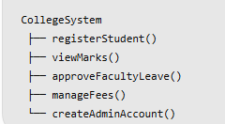
Better design:
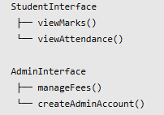

Summary of the four principles
Principle | Main idea | Benefit
OCP | Extend without modifying existing code | Flexibility
LSP | Replace a base type with a valid subtype | Correct substitutability
DIP | Depend on abstractions | Loose coupling
ISP | Use small, focused interfaces | Simplicity

Design Guidelines for Component-Level Design

Design guidelines are rules that help developers prepare software components that are correct, understandable, reusable and easy to maintain.

3.1 Functional independence
Each component should perform a clearly defined task and should interact with other components only when necessary.
Functional independence is evaluated using two important concepts:
- Cohesion: How strongly the internal elements of a module contribute to one purpose.
- Coupling: How strongly one module depends on other modules.
A good design aims for high cohesion and low coupling.
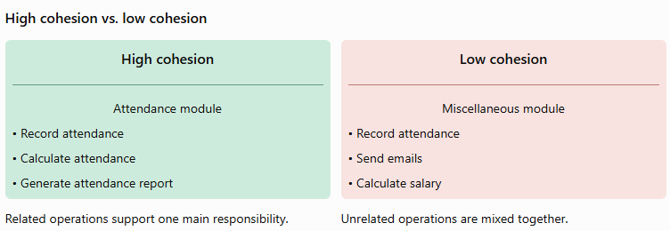

3.2 Information hiding
A component should hide its internal algorithms and data structures from other components unless access is necessary.
For example, a fee-payment component may expose payFee() and getPaymentStatus() without allowing other components to modify its internal transaction records directly.
Benefits:
- Reduces unintended interference.
- Limits the spread of errors.
- Makes changes easier.
- Improves security and maintainability.

3.3 Modularity
A large software system should be divided into manageable modules.
For example:

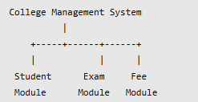
Each module has a defined responsibility. However, creating too many tiny modules increases integration overhead, while too few large modules make the system difficult to understand.
Therefore, a suitable balance between module size and integration effort is required.

3.4 Abstraction
Abstraction focuses on what a component does rather than immediately describing every implementation detail.
Example:
calculateGrade(marks) describes the operation without initially specifying every programming statement used to calculate the grade.

3.5 Stepwise refinement
Stepwise refinement is a top-down approach in which a complex operation is divided into progressively smaller operations until the details are sufficiently clear for coding.

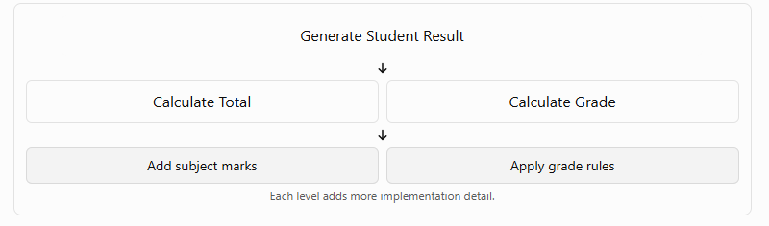

3.6 Simplicity and consistency
- Prefer straightforward algorithms over unnecessarily complex ones.
- Use consistent naming conventions.
- Avoid duplicated logic.
- Keep interfaces simple and predictable.
- Select data structures appropriate to the problem.
- Refactor a design when it can be simplified without changing its external behavior.

3.7 Design for testability and maintainability
A component should be easy to test independently. Its inputs, outputs, dependencies and expected behavior should be clearly defined.
For example, a grade-calculation component can be tested using marks of 95, 60, 35 and invalid inputs without running the entire college management system.

Designing Traditional Components
A traditional software component is a functional program element that contains:
- Processing logic.
- Internal data structures.
- An interface through which it can be invoked and data can be passed.
Traditional components are commonly designed using structured programming principles. Their processing logic is represented using three fundamental constructs: sequence, selection (condition), and repetition (iteration).

1 Sequence
A sequence executes instructions in a specified order.
Example: Calculate the total marks of a student.
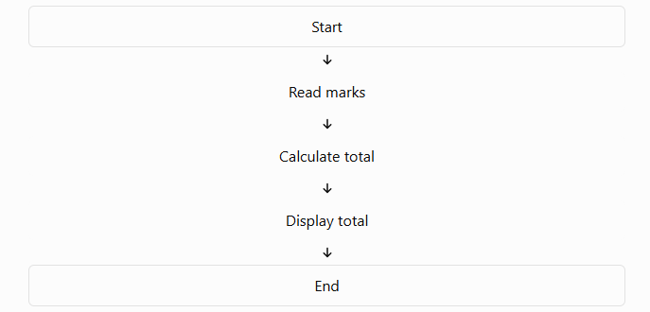
Pseudocode:
START
READ mark1, mark2, mark3
total = mark1 + mark2 + mark3
DISPLAY total
END
Each step follows the previous step. There is no decision or repetition.

2 Selection or condition
Selection chooses one of two or more execution paths based on a condition. It is commonly represented by an if-then-else statement and a decision diamond in a flowchart.
Example: Determine whether a student has passed.
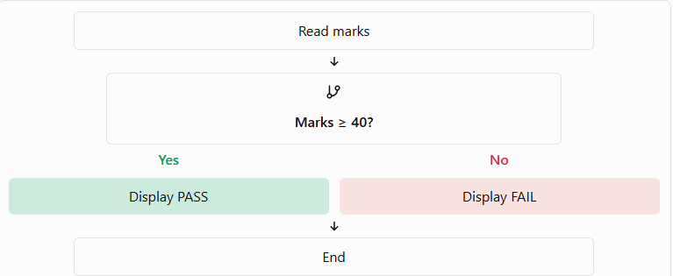
Pseudocode:
READ marks
IF marks >= 40 THEN
DISPLAY "PASS"
ELSE
DISPLAY "FAIL"
END IF

3 Repetition or iteration
Repetition executes a set of instructions multiple times while a condition is satisfied or until a stopping condition occurs.
Two common forms are:
- While / do-while: Repeats based on a condition.
- Repeat-until: Executes the loop and continues until the stopping condition is met.
Example: Calculate the total marks of five students.
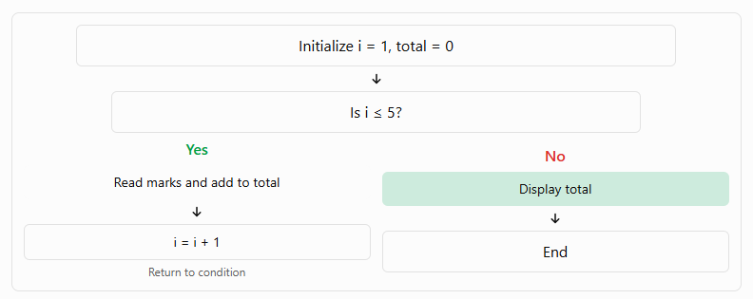
Pseudocode:
total = 0
i = 1
WHILE i <= 5
READ marks
total = total + marks
i = i + 1
END WHILE
DISPLAY total

Comparison of the three constructs
Construct | Purpose | Example
Sequence | Execute steps in order | Calculate total marks
Selection | Choose a path | Pass or fail
Repetition | Execute steps repeatedly | Process marks of many students

Coding Principles and Guidelines
Coding is the process of translating the component design into a programming language such as C, Java, Python or JavaScript.
The main objective is not merely to make a program run, but to make it correct, readable, testable and maintainable.

1.Coding principles
1.1 Follow the design. Implement the algorithms, interfaces and data structures specified in the approved component design.
1.2. Keep modules small and focused. Each function or method should have a clearly defined responsibility.
1.3. Use meaningful identifiers. Variable and function names should explain their purpose.
Poor naming
a = 500
b = 10
c = a * b
Improved naming:
price = 500
quantity = 10
total_cost = price * quantity

1.4. Use structured programming. Prefer clear sequence, selection and repetition constructs over unnecessarily complicated control flow.
1.5. Avoid code duplication. Move repeated operations into reusable functions.
1.6. Validate inputs. Check for invalid, missing or out-of-range values before processing them.
1.7. Handle errors properly. Do not silently ignore exceptions or display misleading success messages.
1.8. Protect data. Avoid exposing passwords, confidential information or internal data unnecessarily.
1.9. Make code testable. Separate business logic from user-interface operations and external dependencies where practical.
1.10. Refactor when necessary. Improve internal code structure without changing the expected external behavior.

Coding guidelines
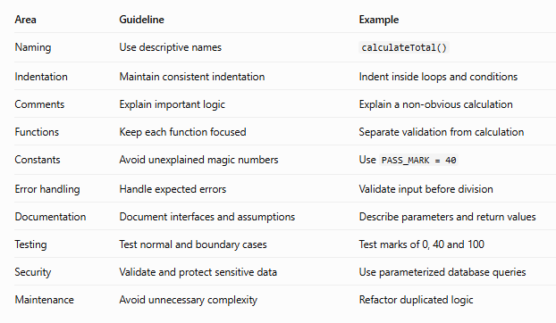

Example: Poor code versus improved code
Poor version:
m = int(input("Marks: "))
if m >= 40:
print("pass")
else:
print("fail")

Improved version:
PASS_MARK = 40
def get_result(marks):
if not 0 <= marks <= 100:
raise ValueError("Marks must be between 0 and 100")
if marks >= PASS_MARK:
return "PASS"
return "FAIL"
marks = int(input("Enter marks: "))
print(get_result(marks))

Relationship between design and coding

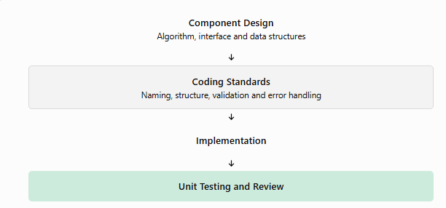

Incremental Development of Code
Incremental development means building a software system in small, manageable pieces rather than implementing the entire system at once.
Each increment adds a defined set of capabilities to the existing working software. The increment is implemented, tested and integrated before the next one is developed.

Example: College management system
Suppose a team is developing a college management application. Instead of developing all features simultaneously, the team can deliver the system in increments.
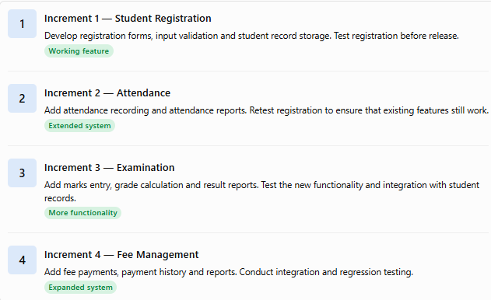

Diagram: Incremental development process

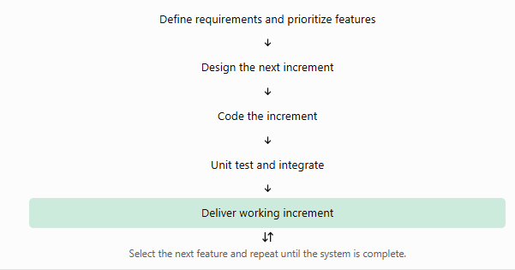

Steps involved
- Identify the complete set of requirements.
- Divide requirements into increments.
- Prioritize features according to importance and dependency.
- Design the selected increment.
- Implement the code using coding standards.
- Perform unit testing and integration testing.
- Deliver the working increment and collect feedback.
- Refine the design where needed and develop the next increment.

Advantages
- Working software becomes available early.
- Errors can be detected before the entire system is completed.
- Testing and debugging are easier to organize.
- User feedback can influence later increments.
- Development progress can be measured clearly.
- Changes can be introduced in manageable steps.

Challenges
- Poor planning may create dependencies between increments.
- Integration problems can occur as features are added.
- Repeated changes may create technical debt without refactoring.
- The team must protect existing features through regression testing.
Important distinction: Incremental development adds functionality in stages. Iterative development improves or revises a solution through repeated cycles. A software project can use both approaches together.

Code Inspection – Planning
Code inspection is a formal, systematic review of source code or another software work product to identify defects before they reach later development stages.
It is a static verification technique: the code is examined without executing it.
The objective is to detect defects such as incorrect logic, missing conditions, interface mismatches, improper data handling, coding-standard violations and potential security problems.

Why is code inspection necessary?
Consider a fee-calculation program that accidentally applies a scholarship discount twice. If the defect is discovered after deployment, it may result in incorrect fee collection and financial reconciliation problems.
A code inspection can identify the duplicate discount operation before the program is executed in production.

Code inspection process
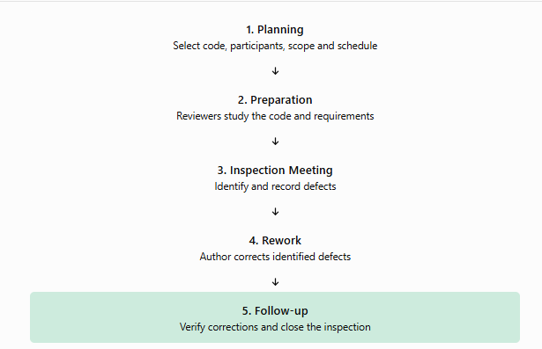

Planning a code inspection
Planning is the first and one of the most important steps in a formal code inspection. A poorly planned inspection may waste time or fail to identify important defects.
The following activities are normally included.
1. Select the work product
Choose the source code, module, algorithm or component to be inspected. The selected work product should be available in a stable version.
2. Define the inspection objectives
Specify what the team needs to verify, such as:
- Correctness of logic and conditions.
- Compliance with coding standards.
- Interface consistency.
- Correct handling of data and exceptions.
- Security and boundary-condition issues.
3. Select participants and assign roles

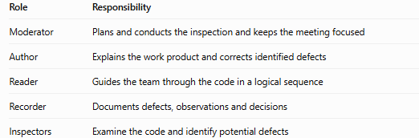
4. Distribute inspection materials
Provide the code, component design, requirements, coding standards and inspection checklist to the reviewers before the meeting.
5. Schedule the inspection
Fix a suitable date, time, duration and scope. Avoid reviewing an excessively large amount of code in one meeting.
6. Establish entry criteria
Before the inspection begins, confirm that:
- The code is complete enough to review.
- The relevant requirements and design are available.
- The code can be understood by the reviewers.
- The necessary documentation and checklists are ready.
7. Conduct individual preparation
Each reviewer studies the code independently, identifies suspicious logic and records potential defects before the meeting.
8. Define exit criteria
Establish how the team will determine that the inspection is complete. This may include recording all identified defects, correcting required defects and verifying the corrections.

Code inspection checklist
Use the following checklist during preparation and inspection.
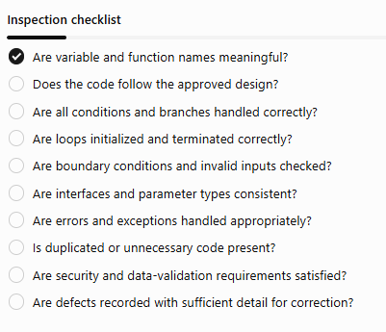

Example of a code inspection
Suppose the following code is submitted for inspection:
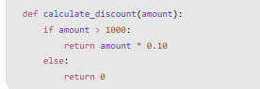
Assume the requirement specifies that purchases of ₹1,000 or more qualify for a 10% discount.
The inspector identifies a boundary-condition defect: the code uses amount > 1000, which excludes a purchase of exactly ₹1,000.
Corrected code:
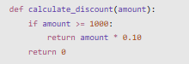
The corrected implementation uses >= to satisfy the stated requirement. Other checks, such as whether negative amounts should be rejected, should also be considered.

Benefits of code inspection
- Detects defects early, before execution or deployment.
- Reduces the cost of fixing defects in later stages.
- Improves compliance with coding standards.
- Encourages knowledge sharing among developers.
- Improves maintainability and code readability.
- Helps identify recurring programming mistakes.

